System of Equations
Definition: A system of equations is TWO LINEAR FUNCTIONS
Ex.
Line 1: y = -3x +5 and Line 2: y = x – 3
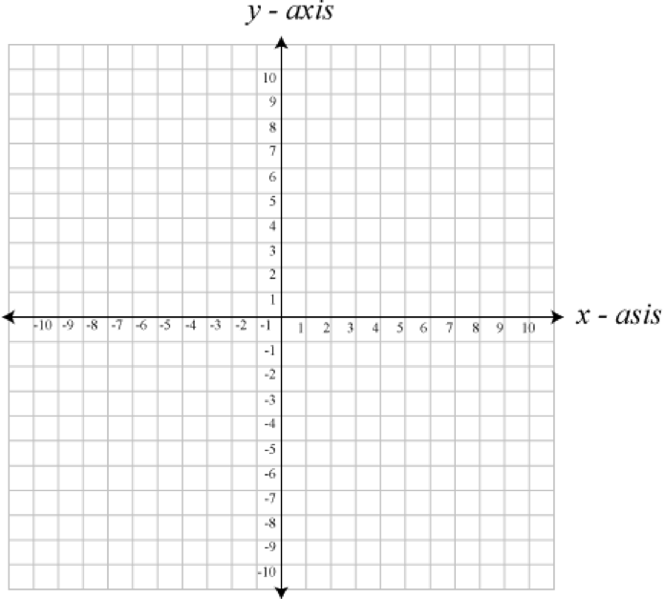Definition: A solution to a system of equations is the point where the two lines intersect
SOLUTION (2, -1)

X | 0 | 2 | 4 | 6
Y (line 1) | 5 | -1 | -7 | -13
Y (line 2) | -3 | -1 | 1 | 3
You can also obtain the solution in a table of values

(warning: may be time consuming)

Systems of equations can be used to determine…
- when 2 situations become equivalent/the same
- 2 unknown values
You just need to come up with the equations
Examples:
- Veronica wants to visit a fish farm. On farm A, the admission fee is $10 plus $4 per catch. On farm B, admission is free but it costs $6 per fish caught. How many fish must Veronica catch for the costs to be equal at both fish farms?

- The sum of two numbers is 56. The difference between the two numbers is two. What are the numbers?

- For an awards banquet, adult tickets cost $15.00 and student tickets cost $10.00. If 140 tickets were sold, and the total amount collected was $1600, how many adults and how many students attended the banquet?

Once you have a system, you can find the solution with a graph or a table of values.
Comparison Method
Solving a system of equations means... Finding the point / coordinate (x, y) where the two lines intersect.
We will do this using ALGEBRA.
Example:
Y = 2x + 1 Y = -3x + 10
Steps to solve system of equations:
- Put the equations side by side and equal to each other
2x + 1 = -3x + 10
- Put all variables on one side and the numbers on the other
2x + 3x = 10 – 1
- Reduce and solve for x
5x = 9
X = 1.8 or 9/5
- Plug in the x value you just solved for into one of the equation (doesn’t matter which one) and solve for y
Y = 2x + 1
Y = 2(1.8) + 1
Y = 4.6
- Write your solution in the form of a (x, y) coordinate

Solution = (1.8, 4.6)
NOTE: Use this method if you have two equations in functional form

Practice!

- y = -x +10
y = 0.5x + 2

- y = 3x – 6
y = x – 2

- y = 1.5x + 7
y = -x – 3

- x = 2y + 4
x = y – 1

- 2y = 6x + 10
-6x + 2y = -2

