Graphing an Inequality
Y ≥ 5x + 2
Step 1 – Make sure the equation is in functional form (y = ax + b) ; otherwise make the change

Y ≥ 5x + 2

If you have to change the inequality – if you divide by a negative number to reduce the “y” variable, you MUST flip the symbol.
Example:
-2y ≤ -10x -4 $\frac{-2y}{-2}$ ≤ $\frac{-10x-4}{-2}$ y $≥$ 5x + 2

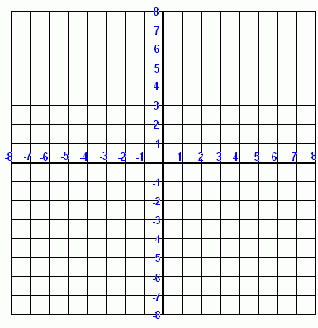
Step 2 – Graph the inequality as though it were a regular equation using one of the 2 methods (intercept method, rise over run)

Step 3 – Determine the type of line and shading for the inequality
“Greater Than” Symbol | > | Dotted Line | Shade Above the Line
“Less Than” Symbol | < | Dotted Line | Shade Below the Line
“Less Than or Equal To” Symbol | ≤ | Solid Line | Shade Below the Line
“Greater Than or Equal to” Symbol | ≥ | Solid Line | Shade Above the Line

Y ≥ 5x + 2

Example #2
2x + 3y – 6 < 0
Step 1 – Make sure the equation is in functional form (y = ax + b) ; otherwise make the change

2x + 3y – 6 < 0 2x + 3y – 6 < 0 3y < -2x + 6 $\frac{3y}{3}$ < $\frac{-2x+6}{3}$

y < $\frac{-2x}{3}$ + 2
Step 2 – Graph the inequality as though it were a regular equation using one of the 3 methods (intercept method, rise over run, or table of values)

Step 3 – Determine the type of line and shading for the inequality
Greater Than Symbol | > | Dotted Line | Shade Above the Line
Less Than Symbol | < | Dotted Line | Shade Below the Line
Less Than or Equal To Symbol | ≤ | Solid Line | Shade Below the Line
Greater Than or Equal to Symbol | ≥ | Solid Line | Shade Above the Line

y < $\frac{-2x}{3}$ + 2

