Graphing a Line
Intercept Method
- We use the intercept method, which requires us to find both the x and y intercepts.
- To find the intercepts we replace each variable with 0 and solve for the other. This will give us two pairs of coordinates to map out and connect to form the line.
Example:
2x + 6y – 18 = 0
Make x = 0
2(0) + 6y – 18 = 0
Isolate and solve for y
This is the y-intercept or point (0,3)
6y – 18 = 0 6y = 18 6y = 18 y = 3
__ __
6 6

Make y = 0
2x + 6(0) – 18 = 0
Isolate and solve for x
This is the x-intercept or point (9,0)
__ __
2 2
2x – 18 = 0 2x = 18 2x = 18 x = 9

With these two points, you can plot them on a Cartesian plane and connect the two points with a line.

Rise Over Run Method
Requirement:
- Equation must be in functional form (y=ax+b)
Example:
Y = 2x + 1
Step 1 – Plot your y-intercept (“b” value) on the y-axis
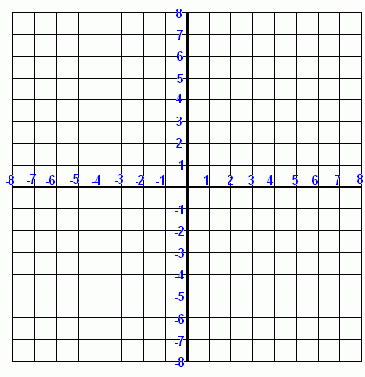
*In all cases the values will be located at (0,b)*

Step 2 – Set your slope (“a” value) up as a fraction
2 = $\frac{2}{1}$

Step 3 – Move from your marked point (y-intercept) using your slope.
Note – positive y means up ; negative y means down ; positive x means right
$\frac{Rise}{Run}$ $\frac{↑ ↓}{→}$
$\frac{Δy}{Δx}$ = $\frac{up or down}{right }$= $\frac{2}{1}$ = $\frac{up 2}{right 1 }$

Step 4 – Connect the two points with a ruler

Try these examples...

3x + 6y – 12 = 0 2x + y = 6 X – 3y + 9 = 0
5x – 5y +5 = 0 2y + 4x = 8 4y = 16

