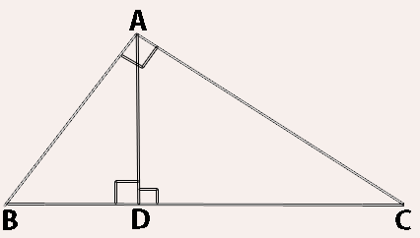Metric Relations in a Right Triangle

There are 3 similar triangles in the illustration above. Can you name them and draw them?
A
B
D
D
A
C
A
B
C

Because there are 3 similar triangles, we can find just about any missing measure in a figure like the one below.

b
h
a

n
m
c

Instead of using proportions to solve, we will use four simple formulas:
a² = m*c
b² = n*c
h² = m*n
a*b = h*c

AND because it’s a right triangle, we can also use Pythagoras!
a² + b² = c²

Ex. Find the missing measures
9
12
c
h
m
n

