Correlation
A correlation between two variables indicates that there exists a relationship between them.
Ex:
- A persons weight and height
- Number of years of school and future income
We can illustrate a two variable distribution on the Cartesian plane by plotting data points (x and y coordinates). This is called a Scatter Plot.
Ex: Age and Diameter of Trees
Diameter (cm)
Age of Tree

A correlation can be positive or negative
- Positive : when both x and y increase
Ex: tree age increases, so does its diameter

- Negative : when x increases and y decreases
Ex: your golf score decreases as years of experience increases

Correlations are also characterized by their strength
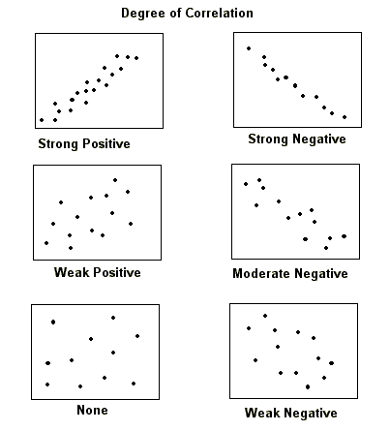

The strength is determined by how closely the scatter plot forms a line.

Correlation Coefficient
To measure the strength of a correlation we need to determine a correlation coefficient (r)
Step 1 – Draw a rectangle around the points (ignoring the outliers)
An OUTLIER is a point that indicates an abnormal piece of data or something out of the ordinary.
It is located far from main cloud of points in the scatter plot.
Diameter (cm)
Age of Tree

Step 2 – Measure the long side (L) and the short side (l)
l = 3 cm
L = 10 cm
Diameter (cm)
Age of Tree

Step 3 – Apply correlation formula
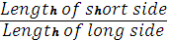
r ≈ ( 1 – ) )
r ≈ (1 – )

r ≈ 0.7 this indicates a moderate positive correlation
Correlation Strength
Correlation Coefficient |  | Meaning
Positive | Negative
Near 0 | Near 0 | Zero
Near 0.5 | Near -0.5 | Weak
Near 0.75 | Near -0.75 | Moderate
Near 0.87 | Near -0.87 | Strong
Near 1 | Near -1 | Perfect
-1
1
0.87
0.75
0.5
0
-0.5
-0.75
-0.87
Negative Correlation
Positive Correlation

