The Sine Law
This formula can allow you to find a missing side or angle in a non-right triangle.
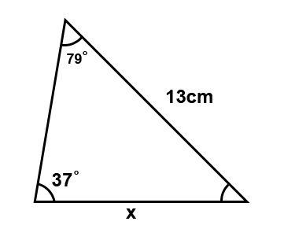
$\frac{a}{sin A}$ = $\frac{b}{sin B}$ = $\frac{c}{sin C}$
A
B
C
a
b
c
Example:
Step 1 – Label the triangle’s angles as
A B and C. Then Label the triangles sides
opposite the angle with the same lower
case letter (side “a” across from angle “A”)

Step 2 – Enter the information you have into the sine law formula
$\frac{x}{sin 79}$ = $\frac{b}{sin B}$ = $\frac{13}{sin 37}$
Step 3 – Knock out the ratio that you don’t need.
$\frac{x}{sin 79}$ = $\frac{13}{sin 37}$
Step 4 – Cross multiply and solve
$\frac{x}{sin 79}$ = $\frac{13}{sin 37}$
$\frac{x}{0.9816}$ = $\frac{13}{0.6018}$
0.6018x = 12.7608
X = 21.2
*NOTE – if you need to solve for a missing angle, remember to do the inverse of the sine that is sin⁻¹

Ship in Distress
A fishing boat gets caught in a storm and the captain calls the coastguard for help. The captain tells the coastguard that their initial distance is 500m from the base of the cliff with an angle of elevation of 15 degrees. By the time the coast guard arrives, the fisherman has drifted to an angle of elevation of 10 degrees and predicts he is 900m from the base of the cliff. Is he right?
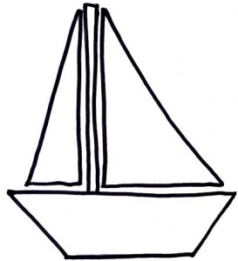
500 m
10°
15°

