System of Inequalities
- 2 or more inequalities will be given
- Solution Set (SS) must be done graphically on the Cartesian plane
- Solution Set (SS) is the common shaded area for all the inequalities given.
Example #1
3x + 6y ≤ 18 & x > 2y – 3
Step 1 – Change the inequalities into functional form (y=ax+b)
3x + 6y ≤ 18 6y ≤ -3x + 18 $\frac{6y}{6}$ ≤ $\frac{-3x}{6}$ + $\frac{18}{6}$ y ≤ $\frac{-1x}{2}$ + 3

x > 2y – 3 2y-3 < x 2y < x +3 $\frac{2y}{2}$ < $\frac{x}{2}$ + $\frac{3}{2}$ y < $\frac{x}{2}$ + 1.5
Step 2 – Graph the inequalities using the inequality chart
Greater Than Symbol | > | Dotted Line | Shade Above the Line
Less Than Symbol | < | Dotted Line | Shade Below the Line
Less Than or Equal To Symbol | ≤ | Solid Line | Shade Below the Line
Greater Than or Equal to Symbol | ≥ | Solid Line | Shade Above the Line
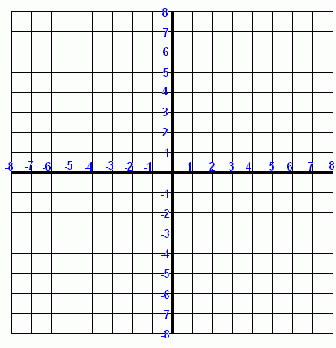

Example # 2
2x + 3y – 6 < 0 & Y ≥ 5x + 3
Step 1 – Change the inequalities into functional form (y=ax+b)
2x + 3y – 6 < 0 3y < -2x + 6 $\frac{3y}{3}$ < $\frac{-2x}{3}$ + $\frac{6}{3}$ y < $\frac{-2x}{3}$ + 2
Y ≥ 5x + 3

Step 2 – Graph the inequalities using the inequality chart
Greater Than Symbol | > | Dotted Line | Shade Above the Line
Less Than Symbol | < | Dotted Line | Shade Below the Line
Less Than or Equal To Symbol | ≤ | Solid Line | Shade Below the Line
Greater Than or Equal to Symbol | ≥ | Solid Line | Shade Above the Line

Practice
-2x + y < 1
3x + 2y > 9

3x + 4y +6 > 0
2x + y ≥ 1

2x ≤ 4
2x + 3y – 6 ≥ 0

x + 2y < 3
4y < -4

