Slope of a Line
How to calculate the slope of a line given two points:
slope = $\frac{Δy}{Δx}$ = $\frac{y2-y1}{x2-x1}$
where (x₁, y₁) & (x₂, y₂) are random points / coordinates
Example #1
A (0, 6)
B (8, 0)

Step 1 – Label the points that you will use as (x₁, y₁) & (x₂, y₂)
A (0,6) will be (x₁, y₁)
B (8,0) will be (x₂, y₂)
Step 2 – Put points (coordinates) into formula
slope = $\frac{Δy}{Δx}$ = $\frac{y2-y1}{x2-x1}$ = $\frac{0-6}{8-0}$
Step 3 – Simplify and reduce fraction
$\frac{0-6}{8-0}$ = $\frac{-6}{8}$ = $\frac{-3}{4}$ or -0.75

Example #2
A (0 ,5)
B (10, 15)
(x₁, y₁)
(x₂, y₂)

Step 1 – Label the points that you will use as (x₁, y₁) & (x₂, y₂)
A (0,5) will be (x₁, y₁)
B (10,15) will be (x₂, y₂)
Step 2 – Put points (coordinates) into formula
slope = $\frac{Δy}{Δx}$ = $\frac{y2-y1}{x2-x1}$ = $\frac{15-5}{10-0}$
Step 3 – Simplify and reduce fraction
$\frac{15-5}{10-0}$ = $\frac{10}{10}$ = 1

x | y
5 | 27.5
9 | 49.5
13 | 71.5
100 | 550
Example #3

Step 1 – Label the points that you will use as (x₁, y₁) & (x₂, y₂)
Point (9,49.5) will be (x₁, y₁)
Point (100,550) will be (x₂, y₂)
Step 2 – Put points (coordinates) into formula
slope = $\frac{Δy}{Δx}$ = $\frac{y2-y1}{x2-x1}$ = $\frac{550-49.5}{100-9}$
Step 3 – Simplify and reduce fraction
$\frac{550-49.5}{100-9}$ = $\frac{500.5}{91}$ = 5.5
Try it again with a different set of points
Step 1 – Label the points that you will use as (x₁, y₁) & (x₂, y₂)
Point (13, 71.5) will be (x₁, y₁)
Point (5, 27.5) will be (x₂, y₂)
Step 2 – Put points (coordinates) into formula
slope = $\frac{Δy}{Δx}$ = $\frac{y2-y1}{x2-x1}$ = $\frac{27.5-71.5}{5-13}$
Step 3 – Simplify and reduce fraction
$\frac{27.5-71.5}{5-13}$ = $\frac{-44}{-8}$ = 5.5
Practice

Determine the slope of the following situations:

1. Point G (-1, 6) & Point W (6, 34)
2. Point K (0.5, 6) & Point V (-1.5, 9)
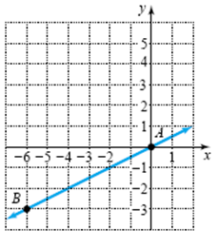
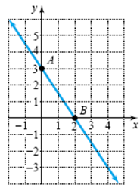
3. 4.

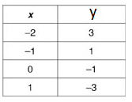
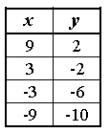
5. 6.

