Optimization of a Function
- Optimization involves determining the best result (vertex) of the polygon of constraint
- The optimal answer will either produce a maximum or minimum depending on the type of problem
- If there is more than one answer (vertex) that optimizes the situation, then every point along that line is considered an answer as well.

Example #1
X ≥ 1
Y ≤ 5
3y ≥ x
Y ≤ -x + 6
Step 1 – Make sure all the inequalities are in function form (y=ax+b)
X ≥ 1
Y ≤ 5
3y ≥ x y ≥ $\frac{1}{3}$x + 0
Y ≤ -1x + 6

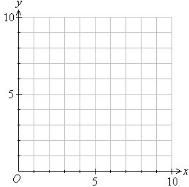
Step 2 – Graph the inequalities & shade the common area
X ≥ 1

Y ≤ 5

y ≥ $\frac{1}{3}$x
Y ≤ -x + 6

A

B

C

Step 3 – Determine the coordinates of your vertices using a system of equations (comparison method)

Vertex A is a given because x = 1 and y = 5 ,therefore the vertex A is (1,5)

Vertex B
Y ≥ $\frac{1}{3}$x & Y ≤ -x + 6

$\frac{1}{3}$x = -x + 6
Make equations equal to one another

$\frac{1}{3}$x + x = 6
LOL (Letters on Left) – Numbers on Right

$\frac{4}{3}$ x= 6
Solve for x
$\frac{\frac{4}{3} }{\frac{4}{3} }$ x= $\frac{6}{\frac{4}{3} }$
X = 4.5 or $\frac{9}{2}$

Y ≤ -x + 6
Y ≤ -(4.5) + 6
Plug “x” into one of the equations
Y ≤ -4.5 + 6
Y ≤ 1.5
Vertex B is located at (4.5, 1.5)

Vertex C
Y ≥ $\frac{1}{3}$x & X ≥ 1
Since you have x ≥ 1
Plug the value of x into the other equation to solve for y
Y ≥ $\frac{1}{3}$x
Y ≥ $\frac{1}{3}$(1)
Y ≥ $\frac{1}{3}$
Vertex C is located at (1, $\frac{1}{3}$)
Step 4 – Determine the optimal value (min or max) using the optimizing function

Example of an optimizing function Revenue = 3x + 8y

Vertices | Revenue = 3x + 8y
A (1,5) | 3(1) + 8(5) = 43
B (4.5, 1.5) | 3(4.5) + 8(1.5) = 25.5
C (1, $\frac{1}{3}$) | 3(1) + 8($\frac{1}{3}$) = 5.$\overline{6}$

Example #2
Y ≤ 3x – 3
Y ≥ $\frac{-1x}{2}$ + 4
Y ≥ $\frac{2x}{3}$ – 3
Y ≤ $\frac{-1x}{2}$ + 7.5

Step 1 – Make sure all the inequalities are in function form (y=ax+b)
Y ≤ 3x – 3
Y ≥ $\frac{-1x}{2}$ + 4
Y ≥ $\frac{2x}{3}$ – 3
Y ≤ $\frac{-1x}{2}$ + 7.5

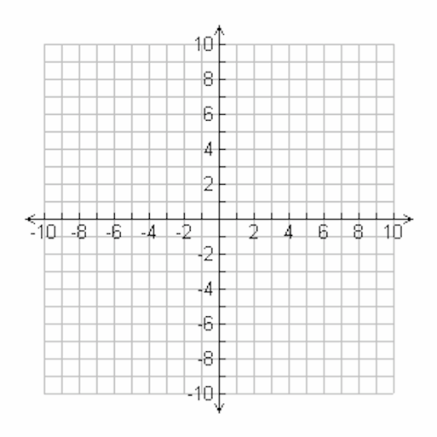
Step 2 – Graph the inequalities & shade the common area

A
D
B

C

Step 3 – Determine the coordinates of your vertices using a system of equations (comparison method)
Vertex A
Y ≤ 3x – 3 & Y ≤ $\frac{-1x}{2}$ + 7.5
3x – 3 = $\frac{-1x}{2}$ + 7.5
3x + $\frac{1x}{2}$ = 7.5 + 3
$\frac{7x}{2}$ = $\frac{10.5}{1}$
7x • 1 = 2 • 10.5
7x = 21
X = 3
Y ≤ 3x – 3
Y ≤ 3(3) – 3
Y ≤ 9 – 3
Y ≤ 6
A (3,6)
Find the coordinates of B, C and D

Step 4 – Determine the optimal value (min or max) using the optimizing function
Vertex | R = 3x + 6y
A (3,6) | 3(3) + 6(6) = 45
B (9,3) | 3(9) + 6(3) = 45
C (6,1) | 3(6) + 6(1) = 24
D (2,3) | 3(2) + 6(3) = 24

Because 2 points produce a optimal (maximum) revenue, the answer will be ALL points on the line between points A and B
*go look at all the graph and pick out ALL the points between A and B (including A and B)*

A
B

