Equation of a Line

Recall : How to calculate the slope of a line given two points

(x₁, y₁) and (x₂, y₂) Slope = y₂ – y₁
_____
x₂ – x₁

The equation of a line in functional form:
b= y-intercept or initial value
a = slope
y = ax + b

To determine the equation of a line from a graph:

Example # 1
A (0 ,5)
B (10, 15)
(x₁, y₁)
(x₂, y₂)

Step 1 – Pick and label two points as (x₁, y₁) and (x₂, y₂)
(0,5) is (x₁, y₁) & (10,15) is (x₂,y₂)

Step 2 – Determine the slope of the line
Slope = $\frac{Δy}{Δx}$ = $\frac{y2-y1}{x2-x1}$ = $\frac{15-5}{10-0}$ = $\frac{10}{10}$ = 1
Step 3 – Plug in a point into the BASE equation to replace the x and the y with actual numbers (also plug in the slope that you just found for the “a”) AND SOLVE!!!!!
Y = ax + b
15 = 1(10) + b
15 = 10 + b
15 – 10 = b
5 = b
Step 4 – Re-write the equation with the “a” and “b” filled in (leave the x and y)
Y = 1x + 5

Example # 2
A (0, 6)
B (8, 0)

Step 1 – Pick and label two points as (x₁, y₁) and (x₂, y₂)
(0,6) is (x₁, y₁) & (8,0) is (x₂,y₂)
Step 2 – Determine the slope of the line
Slope = $\frac{Δy}{Δx}$ = $\frac{y2-y1}{x2-x1}$ = $\frac{0-6}{8-0}$ = $\frac{-6}{8}$ = $\frac{-3}{4}$
Step 3 – Plug in a point into the BASE equation to replace the x and the y with actual numbers (also plug in the slope that you just found for the “a”) AND SOLVE
Y = ax + b
0 = $\frac{-3}{4}$(8) + b
0 = -6 + b
0 + 6 = b
6 = b
Step 5 – Re-write the equation with the “a” and “b” filled in (leave the x and y)
y = $\frac{-3 }{4}$x+ 6

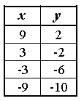
Example #3

Step 1 – Pick and label two points as (x₁, y₁) and (x₂, y₂)
(9,2) is (x₁, y₁) & (-9,-10) is (x₂,y₂)
Step 2 – Determine the slope of the line
Slope = $\frac{Δy}{Δx}$ = $\frac{y2-y1}{x2-x1}$ = $\frac{-10-2}{-9-9}$ = $\frac{-12}{-18}$ = $\frac{2}{3}$
Step 3 – Plug in a point into the BASE equation to replace the x and the y with actual numbers (also plug in the slope that you just found for the “a”)
Y = ax + b
-6 = $\frac{2}{3}$ (-3) + b
Step 4 – Simplify the equation and isolate the “b” to solve for the variable
-6 = $\frac{2}{3}$ (-3) + b
-6 = -2 + b
-6 + 2 = b
-4 = b
Step 5 – Re-write the equation with the “a” and “b” filled in (leave the x and y)
y = $\frac{2}{3}$ x – 4
Sometimes we encounter vertical lines

or horizontal lines

The equation for a vertical line is x = c ; where c is the x-intercept
X = 9
( 9, 0 )

The equation for a horizontal line is y = b ; where b is the y-intercept
y = 6
( 0, 6 )

Practice – Determine the equations of the lines
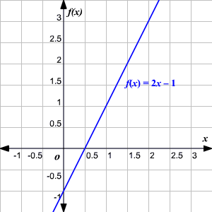

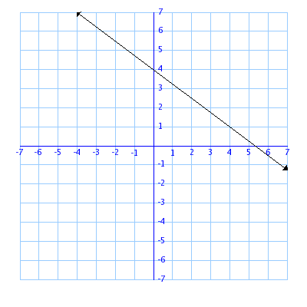

General Form Equation of a Line

Looks like : ax + by + c = 0
a is NOT the slope
b is NOT the y-intercept

So, how do we find the slope and the y-intercept?
Example:
2x + 4y – 6 = 0
Step 1 – Change the equation to functional form by isolating the y variable.

2x + 4y -6 = 0 4y = -2x + 6

Step 2 – Divide both sides of the equation by the coefficient in front of y to get the equation back into the form of y = ax + b

4y = -2x + 6 y = $\frac{-1}{2}$x + 1.5
___ _____
4 4

Slope = -0.5 or -1/2
Y-Intercept = 1.5

Example #2
3x – 6y + 15 = 0 -6y = -3x – 15 Y = ½ x + 2.5

Example #3
-30 + 10y = -2x 10y = -2x + 30 y = $\frac{-1}{5}$x + 3

Example #4
0 = 5y – x -5y = -x y = $\frac{1}{5}$x

Practice – Determine the Slopes and y-intercepts

3x + 4y -12 = 0

-4x + 3y = 24

2x - y = 10

3x + 4y – 36 = 0

-3x - 2y = 48

