Color Theory / Chromatic Number
- Color theory states that the vertices that are connected MUST have different colors
- The minimum # of colors used to color a graph is called the CHROMATIC NUMBER
- Conflicts or Incompatibilities are the links (edges) between two vertices
Example:
Mr. Cloutier needs to create a new seating plan because certain student are overly talkative and cannot sit near each other.
Student | Incompatibilities
Dylan | A,P,S
Andrew | D,S
Patrick | D,K
Sandra | K
Kess | S,A
Step 1 – Draw the graph
A
D
P
S
K

Step 2 - Pick your highest degree - A, D, S and K have a degree of 3 – therefore pick one of them & assign it a color and every other vertex NOT attached to it.
BLUE
A
D
P
S
K
BLUE

Step 3 – Pick the next highest degree and color it and any other vertex that is not directly connected to it the same color. Continue doing this until all the vertices have a color
A
D
P
S
K
BLUE
RED
BLUE
RED
GREEN

The minimum number of colors used (chromatic number) would be 3.

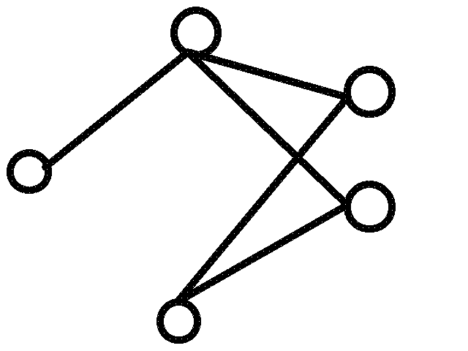
Example #2

Step 1 – Pick the highest degree and assign it and any other vertex not directly connected to it a color
Yellow
Yellow

Step 2 – Pick the next highest degree and color it and any other vertex that is not directly connected to it the same color. Continue doing this until all the vertices have a color
Aqua
Aqua
Yellow
Yellow
Aqua

The chromatic number is 2
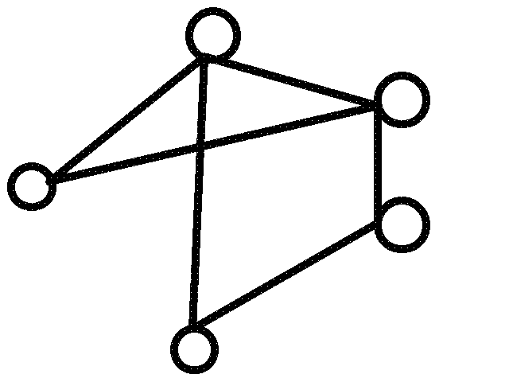
Example #3

Step 1 – Pick the highest degree and assign it and any other vertex not directly connected to it a color
Green

Green

Step 2 – Pick the next highest degree and color it and any other vertex that is not directly connected to it the same color. Continue doing this until all the vertices have a color
Red
Green
Orange
Red

Green

The chromatic number is 3
Example #4
With the mid year exams quickly approaching, we need to create a schedule to ensure that all the students can write the exams and have no conflicts with their courses.
According to the accounting office, the following constraints need to be considered:
Course | Conflicts
Math | Science, History
English | French
French | English
Science | History, Math
History, | Science, Math, French, English

Step 1 – Draw the graph

French
English
History
Science
Math

Step 2 - Pick your highest degree and assign it and any other point NOT directly attached to it with a color

Brown

Step 3 – Pick the next highest degree and color it and any other vertex that is not directly connected to it the same color. Continue doing this until all the vertices have a color
Pink
Blue
The chromatic Number would be 3
Pink
Blue
Brown
French
English
History
Science
Math
French
English
History
Science
Math

