Congruent Triangles
For two triangles to be congruent ALL SIDES must be equal and ALL ANGLES must be equal.
Are these triangles congruent?
7.5 cm
D
E
F
25°
35°
7.5 cm
A
B
C

What about these?
D
E
F
8cm
50°
A
B
C
8cm
50°

When you are given limited information about any pair of triangles, there are three ways to tell whether or not they are congruent
Theorem 1 – Side Side Side (SSS)
If all 3 sides measure the same in both triangles, they are congruent.
A
B
C
D
E
F
5cm
5cm
9cm
6cm
6cm
9cm

Theorem 2 – Side Angle Side (SAS)
If 2 sides measure the same in both triangles and the angles between those 2 sides is also the same, they are congruent.
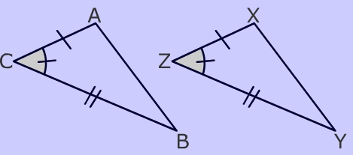

*Be careful with the orientation of the triangles – flip them around and re-draw them if necessary. Make sure you are looking at the triangles in the same views.
Theorem 3 – Angle Side Angle (ASA)
If 2 angles measure the same in both triangles and the side between those 2 angles is also the same, they are congruent.
